Create a Flow using Power Automate

1. Go to -

[https://flow.microsoft.com](https://flow.microsoft.com/)

Sign in as Holly (full address)

Select UK region

2.

Left pane - Click 'Connectors'

Select 'Sharepoint' from the 'All connectors' section

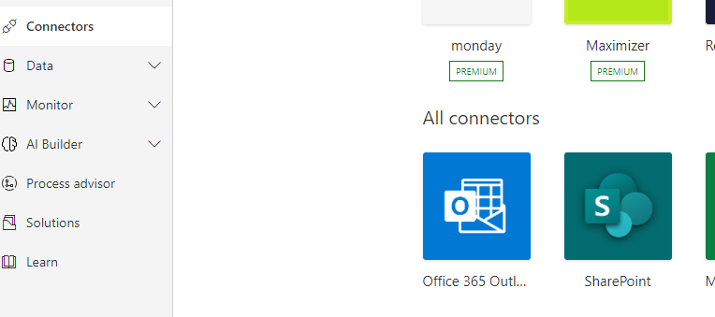

3.

Select 'When an item is created or modified'

Tnggers - trigger is 
When a file is classified by 
Wnen a 
content understanding model 
(proped 
When a file is created or 
Wnen a 
modified (properties only) 
Wnen a 
mod' 

4.

Site address drop-down - select 'IT Services…'

List name - select 'Service Desk Requests'

When an item is created or modified 
O 
•site 
• List Name 
IT - 
SharePointli3t name 
Service Desk Requests 
Show advanced option 
Enter custom 

Select Advanced options and select 'Active Cases'

Click on '+ New Step'

When an item 
is created or modified 
• Site Address 
List 
Desk Request' 
Limit Columns 
Acti•æ 
Hide advanced options A 
Nices2 V 

5.

Choose an operation - type outlook and select 'Office 365 outlook'

When an item is created or modified 
Choose an operation 
out'" 
All Built-in 
Office SS 
Standard 
O ubook 
Premium 
Custom 
My dipboard 
Connect 
Outlook 

6.

Select 'Send an email (V2)

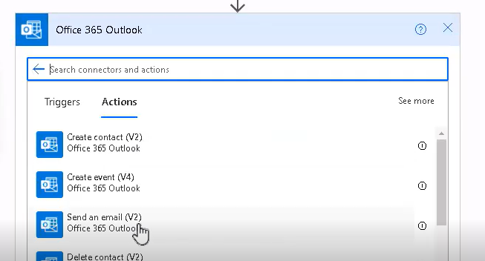

7.

To:

MOD Administrator

Subject / click 'add dynamic content'

Select 'Issue Title'

Send an email 0/2) 
bdmin@M365xC19D3407.onMicrosofecom 
Subject 
issueTiee x I 
Add 
Add dynamic content from the 
connectors used in this flow, 
apps 
and 
Hide 
Font 
Specify the body of the 
options V 
+ New step 
thnamic content 
Expression 
p Search dynamic content 
Customs 
Customs JobTitIe 
Location 
issueTitIe 

Body - copy the following:

A service request ticket submitted by < Customer DisplayName > and assigned to < Assign To DisplayName > was added or edited.

8.

Click 'show advanced options'

Change Importance field to 'Normal' and click Save at the bottom

From 
Email address to send mail from (requires •Send as" or "Send on beha 
Specify email addresses separated by semicolons like someone@conb 
Specify email addresses separated by semicolons like someone@contl 
Att.chm,ents -l 
Arachment name 
Attachment; Content • 
Ahachment content 
+ Add 
Hide • dwnced options A 
Rep* To 
Importance 
Sensitivity 
The email addresses to use when replying 
Normal 
New step 
options 

9.

Change title on top left of page. Double click and change to:

Service Request flow for new or modified tickets

f— iervice Request flow for new,hnodified tickets 
is readyto go. We recommend it 
Vfnen an item is cru 

10.

Top right - select 'Flow checker'

Should be 0 errors:

Flow 
Errors(O) 
v Warnngs (O) 
x 

Close flow checker

11.

Click 'Test Flow' on top right

Check Manually

Click on 'Save & Test' at the bottom

Test Flow 
- - 一 d to -99 : 